FACULTY EVALUATION
Programme Name: Resource Mobilization Programme
Session: Proposal development: Budgeting
Faculty Name: Emmanuel Munyasia
No. of Respondents: 9
No. of Participants: 10
Evaluation Parameter | (%) Individual Score | (%) Programme Average
Punctuality | 100 | 96
Clarity of presentation | 96 | 94
Degree of preparation | 96 | 94
Course design & org | 96 | 91
Content & methodology | 93 | 93
Quality of discussions | 96 | 94
Relevance to work | 96 | 95
Average scores | 96 | 94

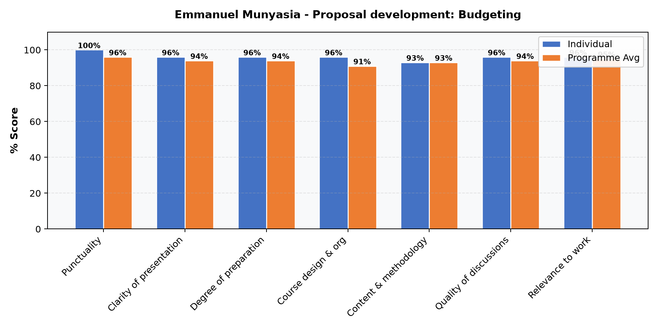

Comments & Feedback
- • Have deeper sessions on budgeting
- • Good trainers with knowledge
SUBMITTED THROUGH:
NAME: ______________________ SIGN: ______________________ DATE: ______________________

